**DLD Lab 06**

(Software)

**23K-2001**  
Muzammil Siddiqui  
BCS 2-J

**Q1.**

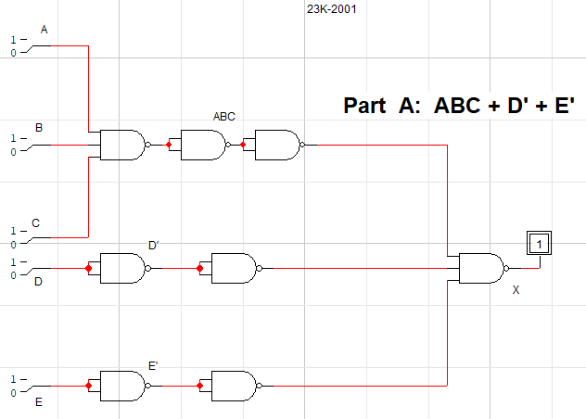

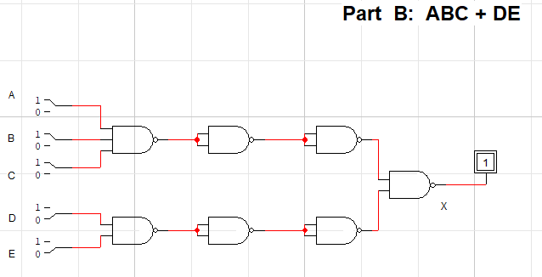

**Q2.**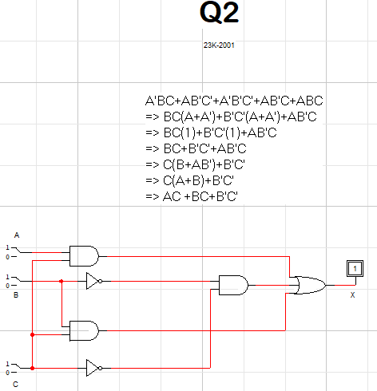

Simplification using Boolean Algebra:

Q2.

A’BC+AB’C’+A’B’C’+AB’C+ABC

=>BC(A’+A)+B’C’(A+A’)+AB’C

=>BC(1)+B’C’(1)+AB’C

=>C(B+AB’)+B’C’

=>C(A+B)+B’C’

=>AC+BC+B’C’

**Q3.**

1. 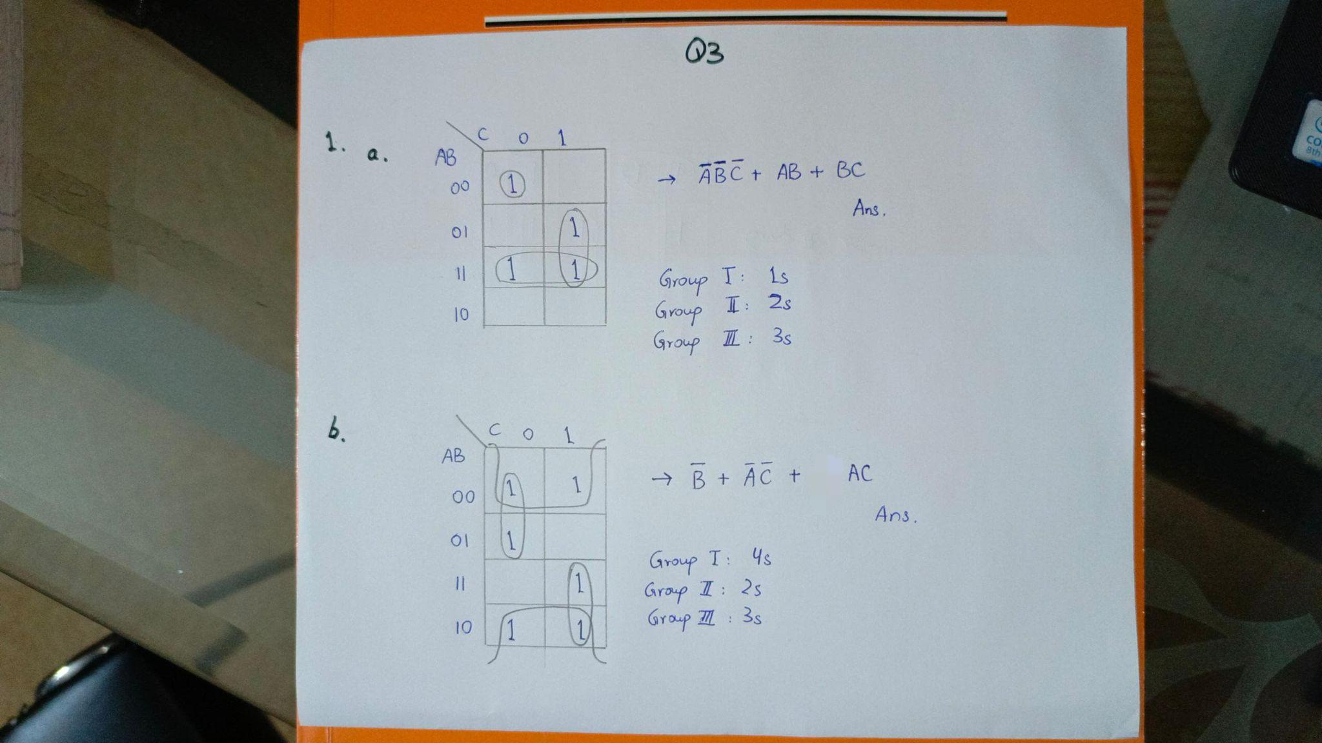
2. 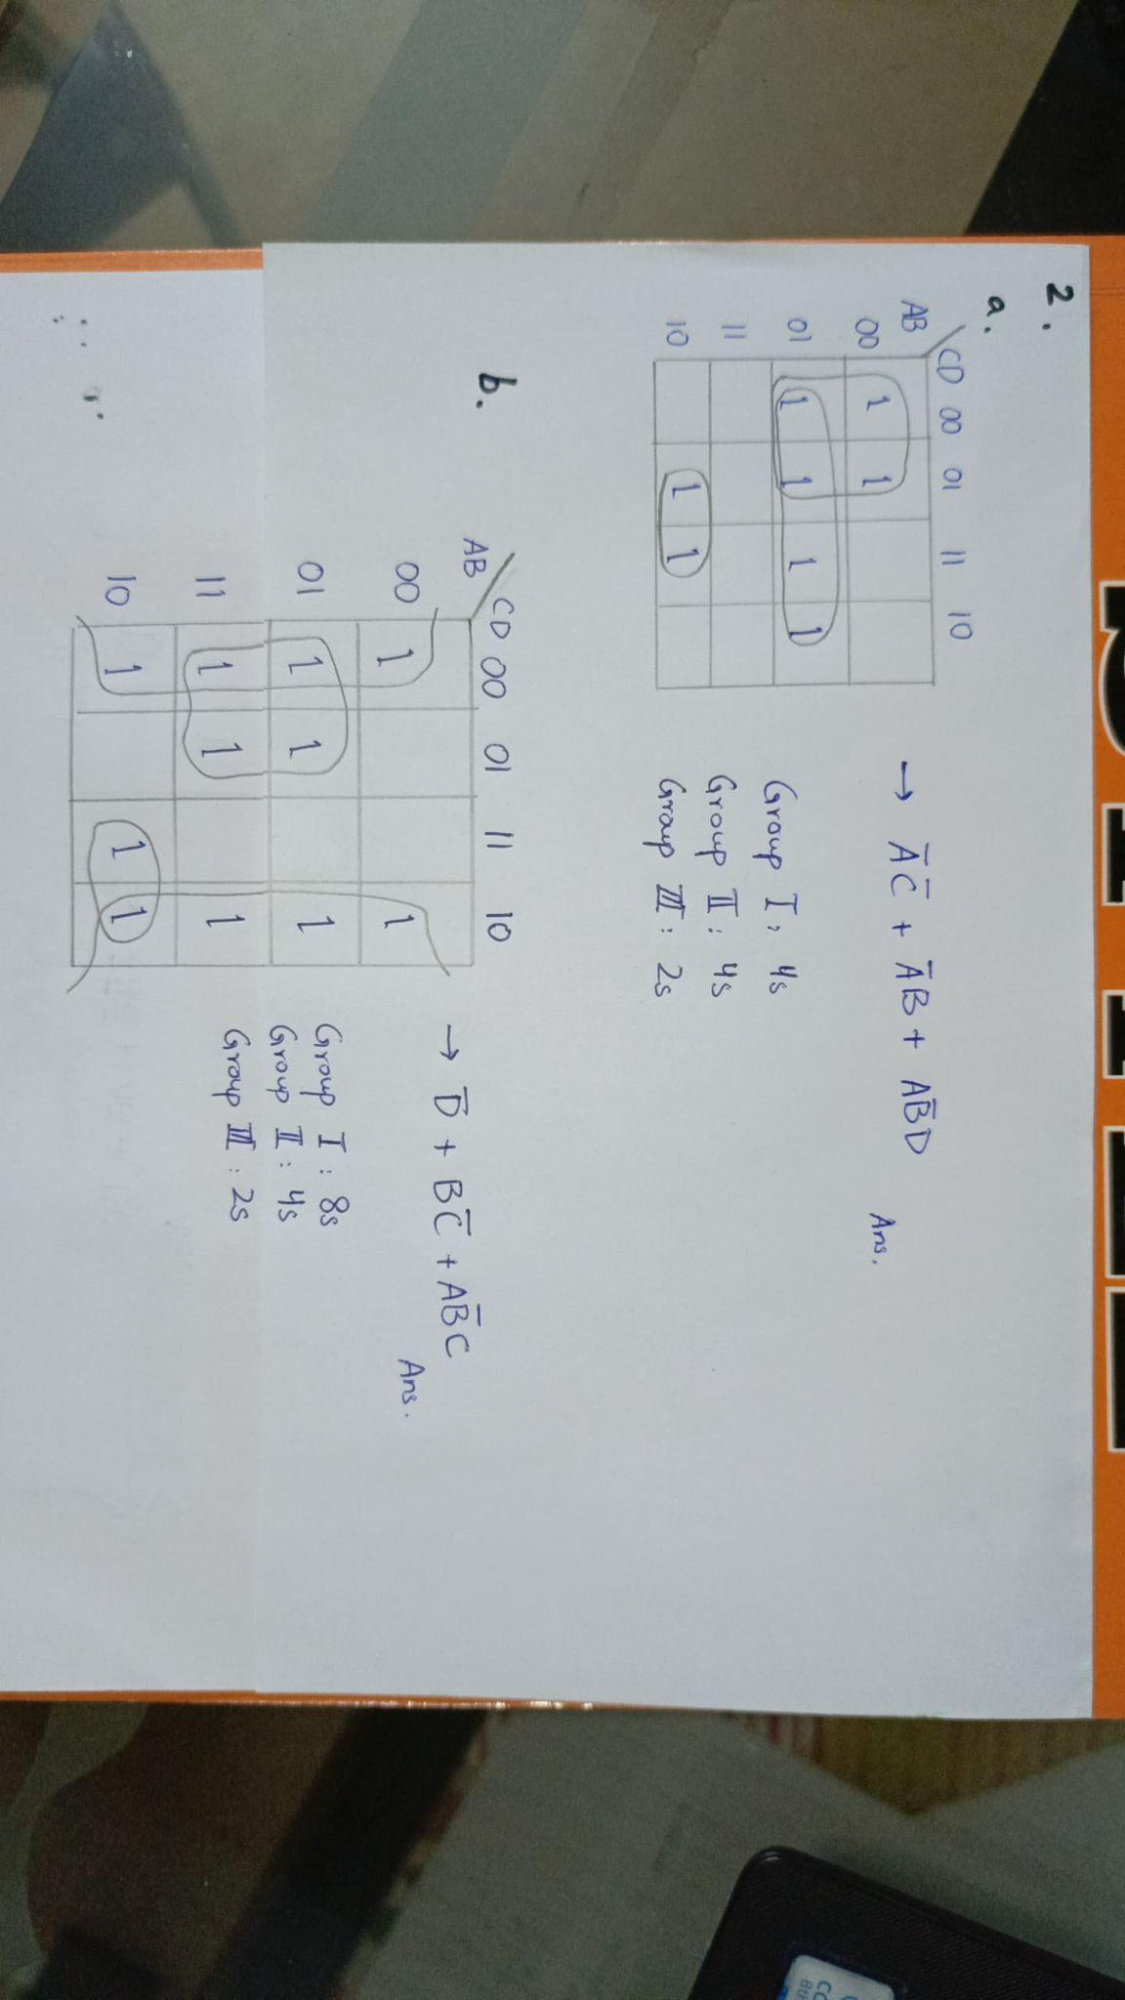

**Q4.**

Simplification:  
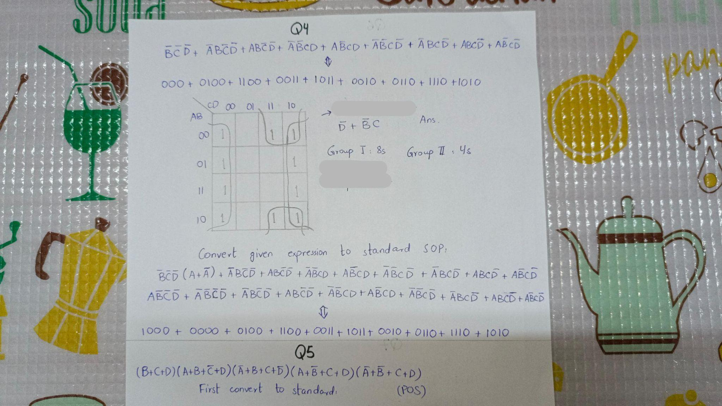

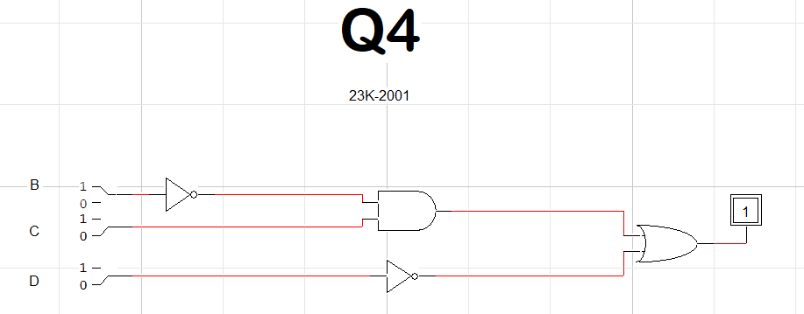

Truth table:

**X = D’+B’C**

|  |  |  |  |  |
| --- | --- | --- | --- | --- |
| **A** | **B** | **C** | **D** | **OUTPUT** |
| 0 | 0 | 0 | 0 | 1 |
| 0 | 0 | 0 | 1 | 0 |
| 0 | 0 | 1 | 0 | 1 |
| 0 | 0 | 1 | 1 | 1 |
| 0 | 1 | 0 | 0 | 1 |
| 0 | 1 | 0 | 1 | 0 |
| 0 | 1 | 1 | 0 | 1 |
| 0 | 1 | 1 | 1 | 0 |
| 1 | 0 | 0 | 0 | 1 |
| 1 | 0 | 0 | 1 | 0 |
| 1 | 0 | 1 | 0 | 1 |
| 1 | 0 | 1 | 1 | 1 |
| 1 | 1 | 0 | 0 | 1 |
| 1 | 1 | 0 | 1 | 0 |
| 1 | 1 | 1 | 0 | 1 |
| 1 | 1 | 1 | 1 | 0 |

**Q5.**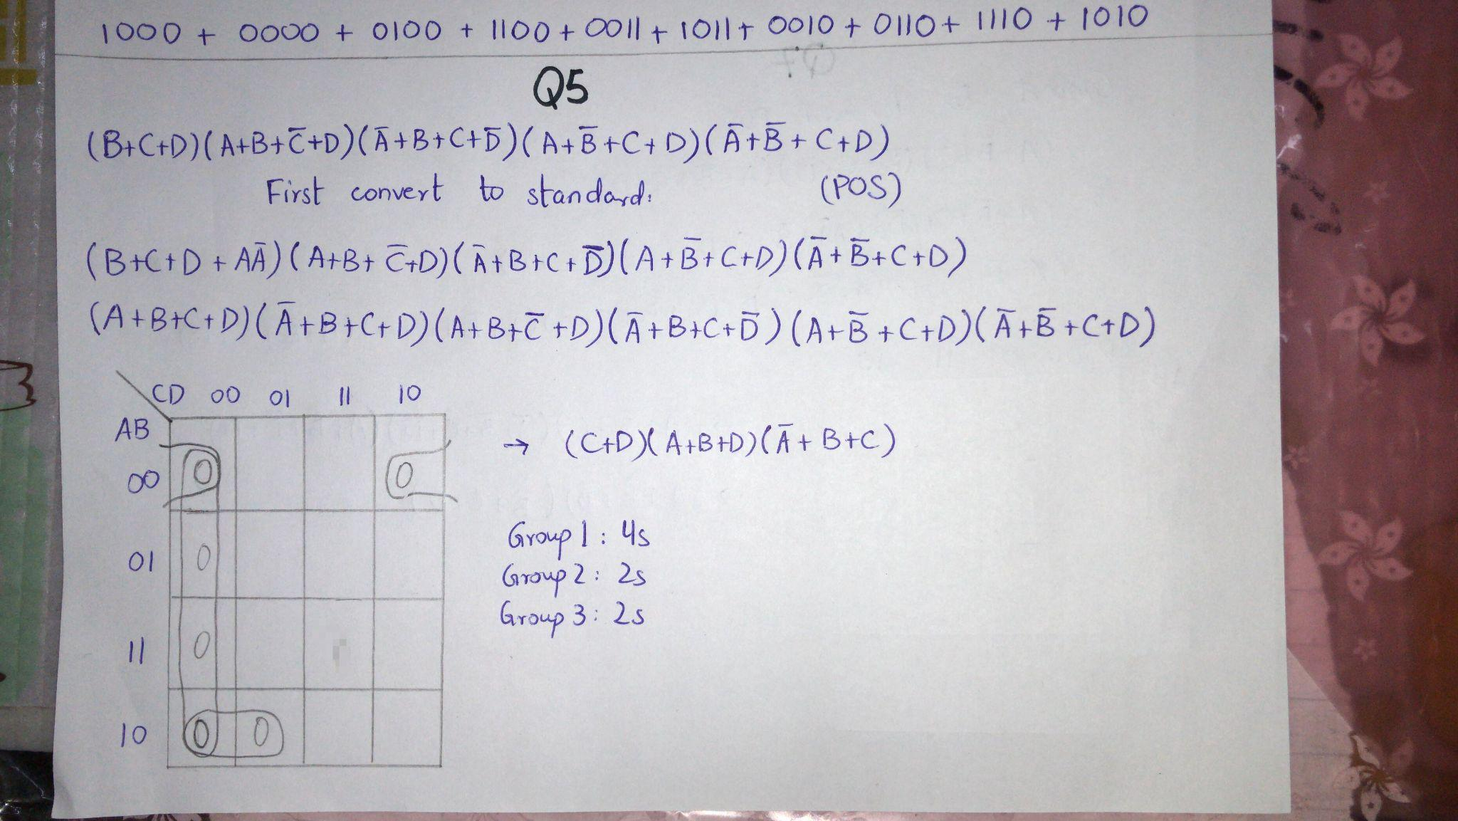

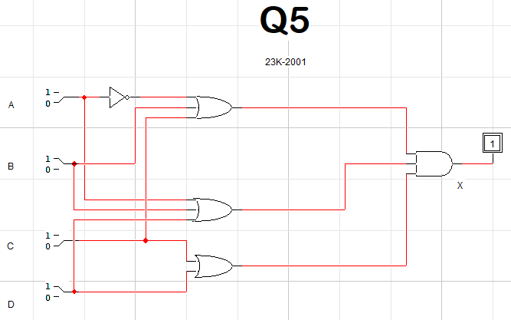

Truth Table:

**X = (C+D)(A+B+D)(A’+B+C)**

|  |  |  |  |  |
| --- | --- | --- | --- | --- |
| **A** | **B** | **C** | **D** | **OUTPUT X** |
| 0 | 0 | 0 | 0 | 0 |
| 0 | 0 | 0 | 1 | 1 |
| 0 | 0 | 1 | 0 | 0 |
| 0 | 0 | 1 | 1 | 1 |
| 0 | 1 | 0 | 0 | 0 |
| 0 | 1 | 0 | 1 | 1 |
| 0 | 1 | 1 | 0 | 1 |
| 0 | 1 | 1 | 1 | 1 |
| 1 | 0 | 0 | 0 | 0 |
| 1 | 0 | 0 | 1 | 0 |
| 1 | 0 | 1 | 0 | 1 |
| 1 | 0 | 1 | 1 | 1 |
| 1 | 1 | 0 | 0 | 0 |
| 1 | 1 | 0 | 1 | 1 |
| 1 | 1 | 1 | 0 | 1 |
| 1 | 1 | 1 | 1 | 1 |

**Q6.**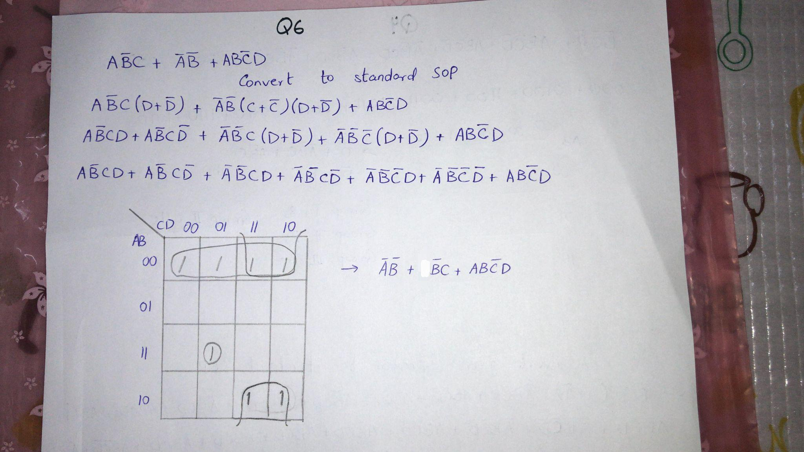

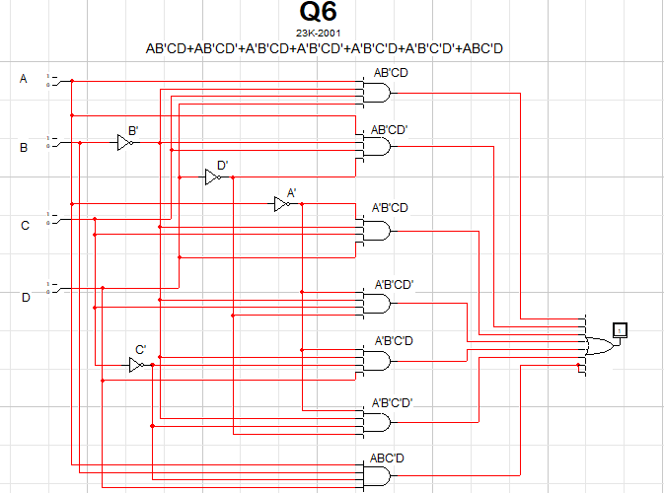

**Truth Table:**

**X = A’B’+B’C+ABC’D**

|  |  |  |  |  |
| --- | --- | --- | --- | --- |
| **A** | **B** | **C** | **D** | **OUTPUT X** |
| 0 | 0 | 0 | 0 | 1 |
| 0 | 0 | 0 | 1 | 1 |
| 0 | 0 | 1 | 0 | 1 |
| 0 | 0 | 1 | 1 | 1 |
| 0 | 1 | 0 | 0 | 0 |
| 0 | 1 | 0 | 1 | 0 |
| 0 | 1 | 1 | 0 | 0 |
| 0 | 1 | 1 | 1 | 0 |
| 1 | 0 | 0 | 0 | 0 |
| 1 | 0 | 0 | 1 | 0 |
| 1 | 0 | 1 | 0 | 1 |
| 1 | 0 | 1 | 1 | 1 |
| 1 | 1 | 0 | 0 | 0 |
| 1 | 1 | 0 | 1 | 1 |
| 1 | 1 | 1 | 0 | 0 |
| 1 | 1 | 1 | 1 | 0 |

**Q7.**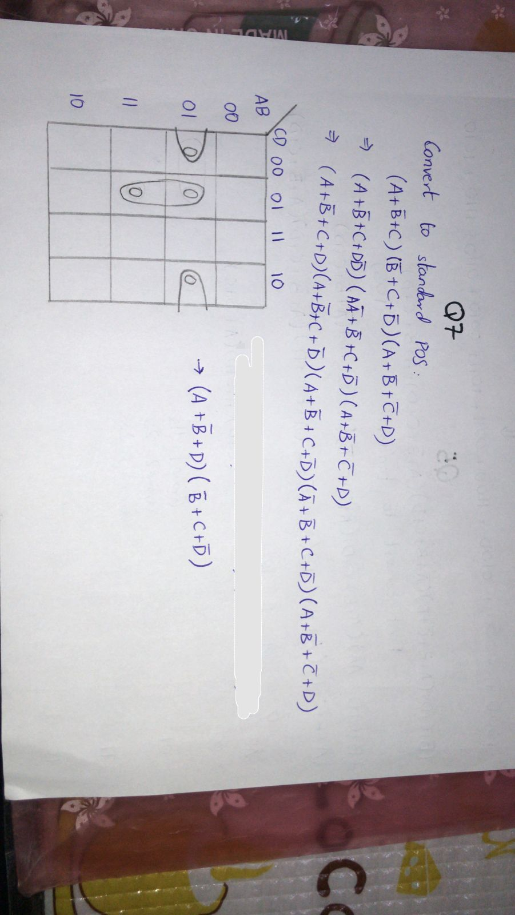

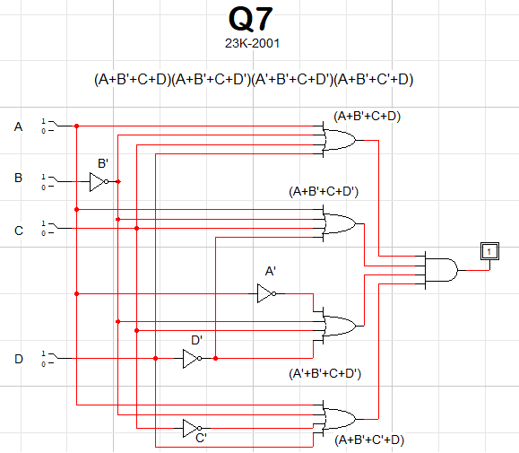

**TRUTH TABLE:**

**X = (A+B’+D)(B’+C+D’)**

|  |  |  |  |  |
| --- | --- | --- | --- | --- |
| **A** | **B** | **C** | **D** | **X** |
| 0 | 0 | 0 | 0 | 1 |
| 0 | 0 | 0 | 1 | 1 |
| 0 | 0 | 1 | 0 | 1 |
| 0 | 0 | 1 | 1 | 1 |
| 0 | 1 | 0 | 0 | 0 |
| 0 | 1 | 0 | 1 | 0 |
| 0 | 1 | 1 | 0 | 0 |
| 0 | 1 | 1 | 1 | 1 |
| 1 | 0 | 0 | 0 | 1 |
| 1 | 0 | 0 | 1 | 1 |
| 1 | 0 | 1 | 0 | 1 |
| 1 | 0 | 1 | 1 | 1 |
| 1 | 1 | 0 | 0 | 1 |
| 1 | 1 | 0 | 1 | 0 |
| 1 | 1 | 1 | 0 | 1 |
| 1 | 1 | 1 | 1 | 1 |